FRACTIONS OF AN AMOUNT
Pearson Edexcel - Thursday 4 June 2020 - Paper 2 (Calculator) Foundation Tier

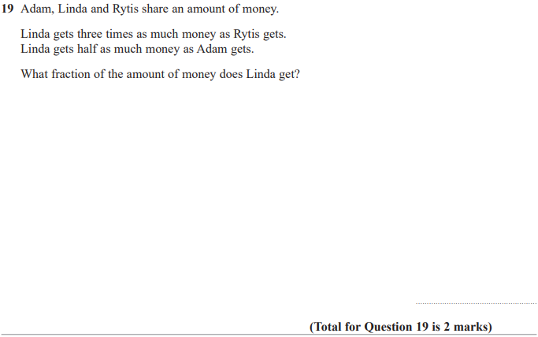

Pearson Edexcel - Monday 8 June 2020 - Paper 3 (Calculator) Foundation Tier

Pearson Edexcel - Tuesday 21 May 2019 - Paper 1 (Non-Calculator) Foundation Tier

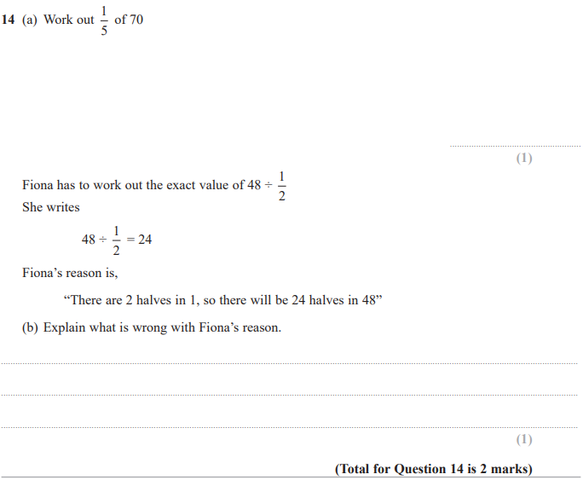

Pearson Edexcel - Tuesday 11 June 2019 - Paper 3 (Calculator) Foundation Tier

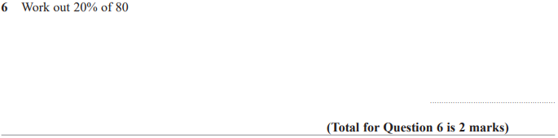

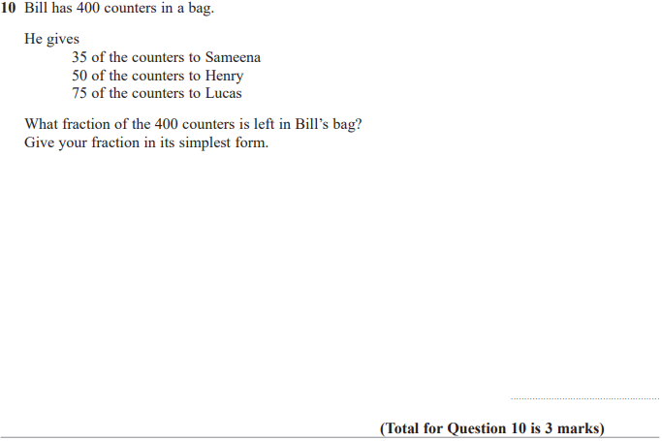

Pearson Edexcel - Monday 12 November 2018 - Paper 3 (Calculator) Foundation Tier

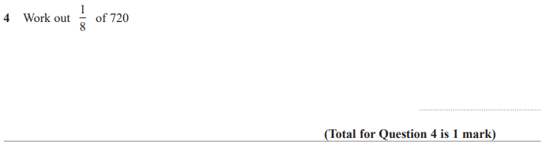

Pearson Edexcel - Thursday 24 May 2018 - Paper 1 (Non-Calculator) Foundation Tier

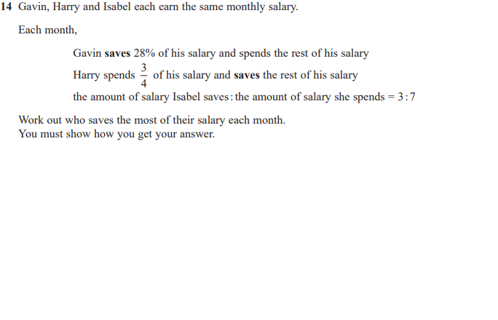

Pearson Edexcel – Specimen 2 - Paper 2 (Calculator) Foundation Tier

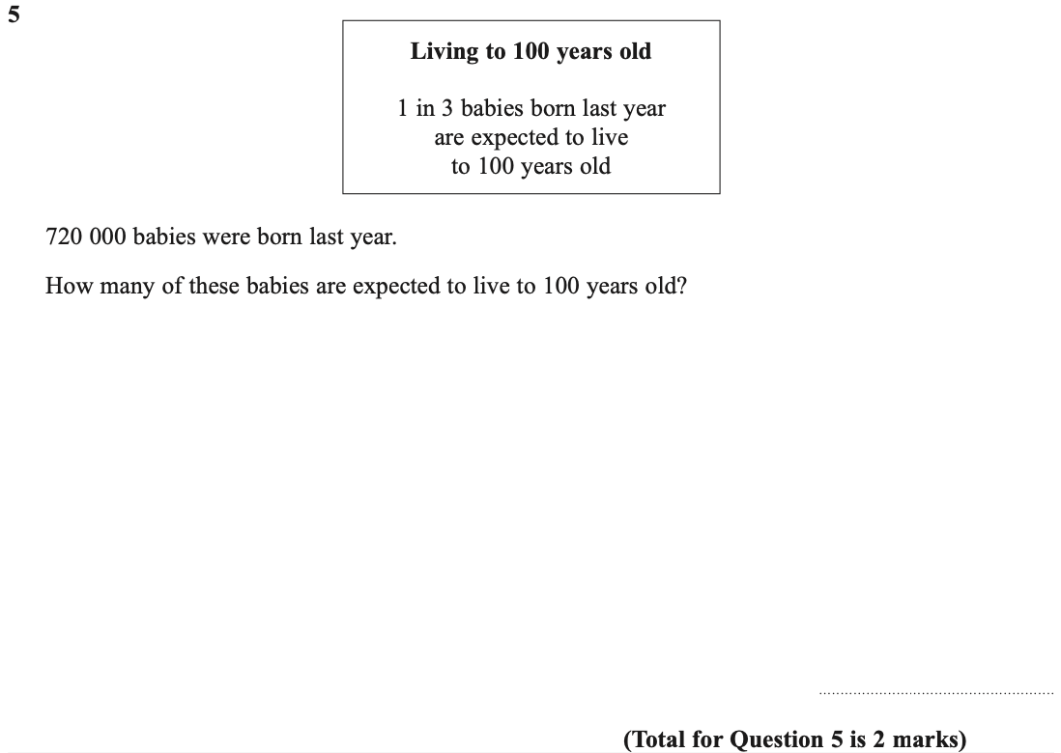

Pearson Edexcel – Specimen 1 - Paper 1 (Non-Calculator) Foundation Tier

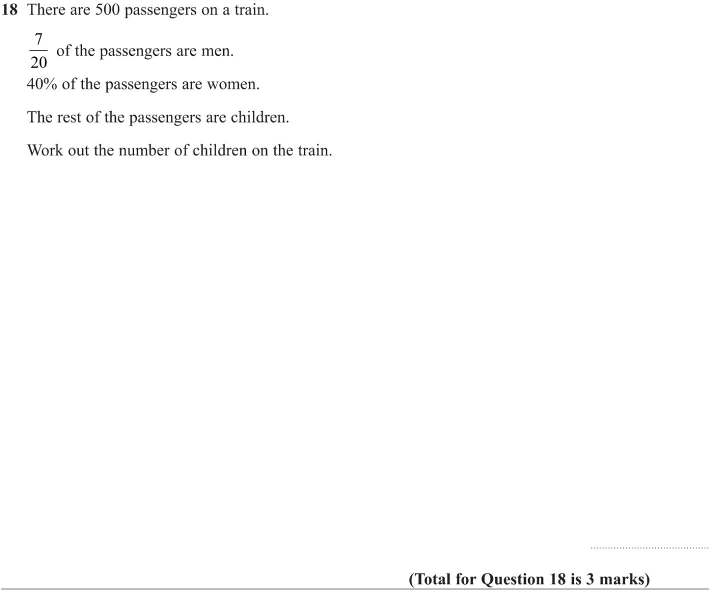

Pearson Edexcel – Specimen 1 - Paper 2 (Calculator) Foundation Tier

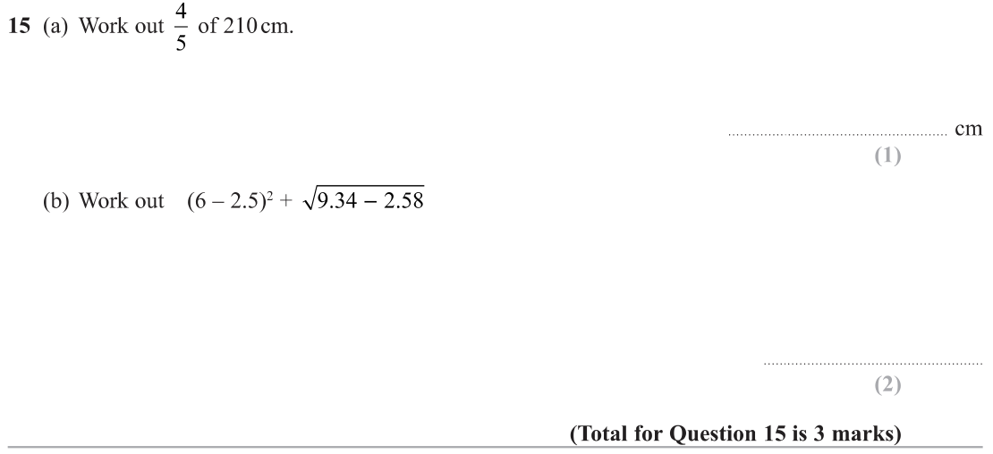

OCR – Tuesday 03 November 2020- Morning - Paper 1 (Calculator) Foundation Tier
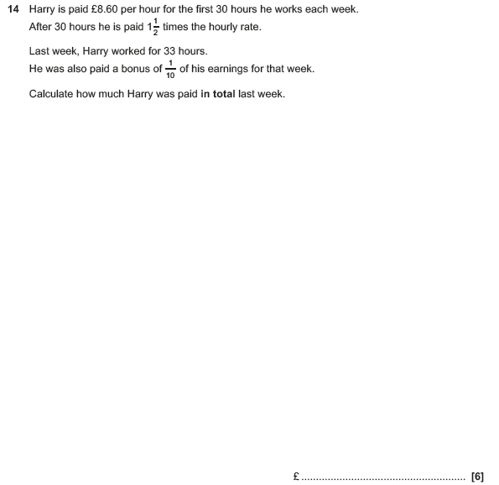

OCR Thursday 6 June 2019 – Morning (Non-Calculator) Foundation Tier
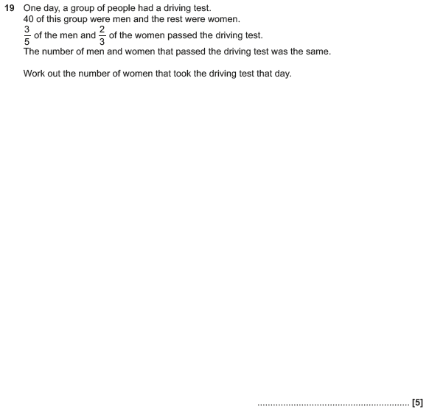

OCR Tuesday 11 June 2019 – Morning (Calculator) Foundation Tier
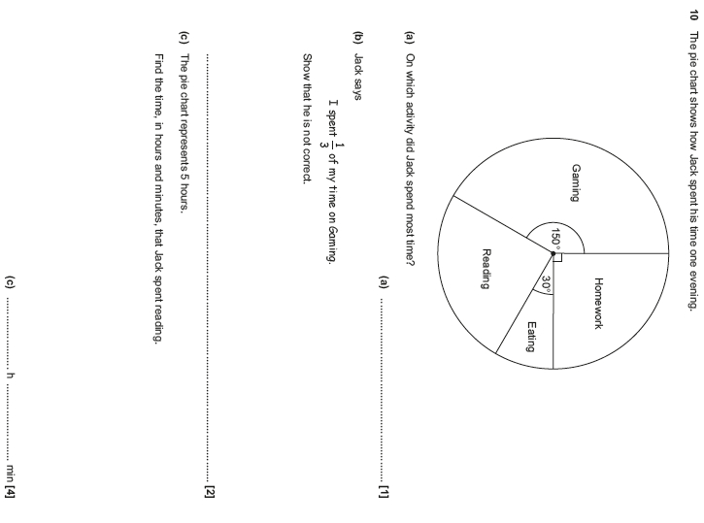

OCR Thursday 8 November 2018 – Morning (Non-Calculator) Foundation Tier

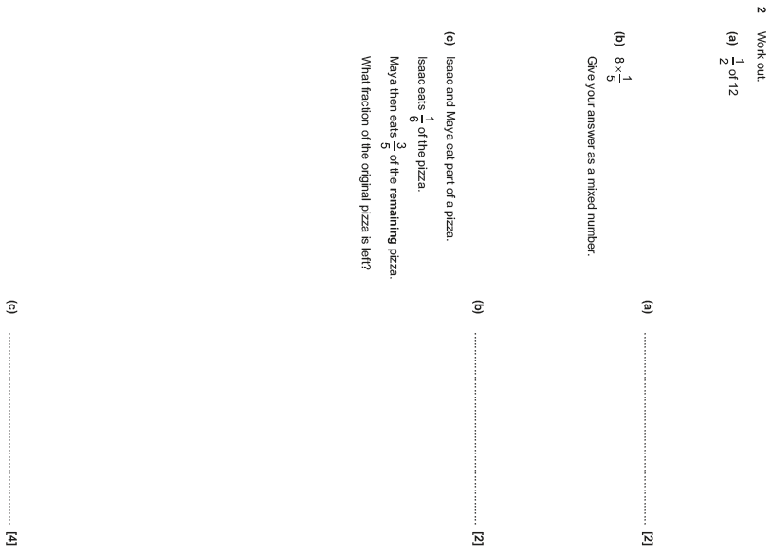

OCR Thursday 7 June 2018 – Morning (Non Calculator) Foundation Tier

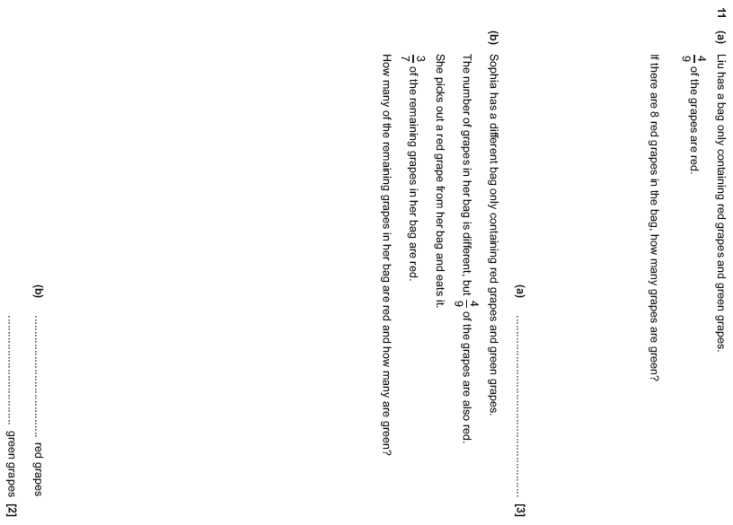

Pearson Edexcel – Sample Papers - Paper 3 (Calculator) Foundation Tier

